 | Education  Certification  Membership  Career Center
_____________________________________________________________________________________

The Greater Nashville Area SoCRA Chapter will offer the following programs:
**********************************************************************************************
In compliance with Covid-19 social distancing requirements the following process will be followed:

- The meetings will be conducted remotely.
- In order to register for the meeting please complete the following REDCap survey https://redcap.vumc.org/surveys/?s=9WLPFCC9WPNNLLEH . Upon registration completion a meeting password and the link to the meeting will be sent to the email entered into the survey.
- Actual attendance will be documented via emailing kate.vonwahlde@vumc.org during or immediately following the meeting. Following the meeting:
  - SoCRA members will be emailed a copy of the SoCRA attendance certificate
  - Non SoCRA members can track attendance via VUMC CME website and/or their own CE tracking method.
  - A unique VUMC CME code will be provided during the meetings, the code is valid for 24 hours.

Highlights of the 2025 SoCRA Annual Conference | 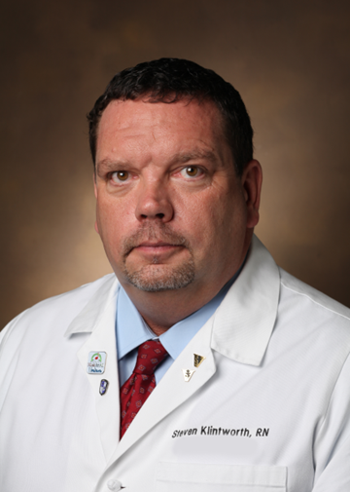  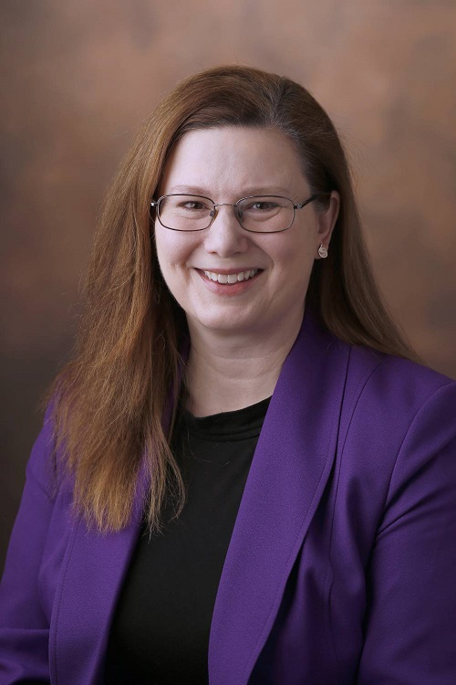
Speakers:
Steven Klintworth, RN, BSN, MSHS, CCRP
Research Nurse Specialist IV
Department of Pediatrics Center for Clinical and Translational Research
Monroe Carell Jr. Children’s Hospital at Vanderbilt

Annette Oeser, MA Bioethics, MLAS, CIM, CCRP
Regulatory Compliance Analyst
VUMC Human Research Protections Program
December 4, 2025 │ 12 – 1 pm Central
This presentation will cover some of the highlights of the 2025 SoCRA Annual Conference, including ethics in research, combating burnout in clinical research professionals, interest in clinical trials in rural communities, and ethical considerations for cell and gene therapy clinical trials.

Accreditation: Vanderbilt University Medical Center is accredited by the Accreditation Council for Continuing Medical Education (ACCME) to provide continuing medical education for physicians. Vanderbilt University Medical Center designates this live activity for a maximum 1.00 AMA PRA Category 1 Credit(s)™. Physicians should claim only the credit commensurate with the extent of their participation in the activity.
Commercial Support: This activity received no commercial support.
Financial Disclosures: Faculty and planners for this event have the following disclosures:
Name of individual Individual's role in activity Name of commercial interest/Nature of relationship
Annette Oeser, MA Bioethics, MLAS, BS, CIM, CCRP Faculty: Nothing to disclose – 07/03/2025
Steven Klintworth, RN, BSN, MSHS, CCRP Faculty: Nothing to disclose – 8/1/2025

Attendance: Members and non-members welcome. Please bring your lunch. For directions, please contact wendy.lloyd@vumc.org .
CE: SoCRA has approved this program for 1.0 continuing education contact hour for members. Please share this announcement with your colleagues.
Future Correspondence: SoCRA has sent this email for educational purposes only. If you no longer wish to receive emails from SoCRA, please contact the SoCRA office at office@socra.org .

