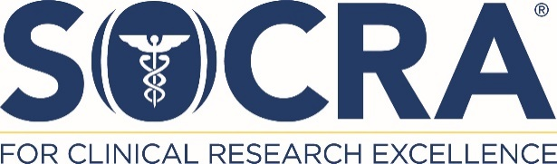

SOCRA San Francisco Bay Area CHAPTER MEETING

Date: July 30th 2026

Time: 12.00 PM PST

Location: Virtual

Title / Topic: Using AI for Inspectional Readiness: The One Day Pilot or the Routine Inspection

Speaker
Mr. Eric Pittman
Adjunct Professor of Pharmacy at Temple University
Vice President Quality Assurance and
Regulatory Affairs at Project Farma,
PerkinElmer company
Eric is a seasoned professional with more than 20 years of experience at the U.S. Food and Drug Administration, where he conducted extensive inspections across the pharmaceutical, medical device, Bioresearch Monitoring (BIMO), and food sectors. Throughout his FDA tenure, he played a key role in developing inspectional policies and implementing new programs driven by emerging laws and regulations. Eric concluded his FDA career as the Division Director for Bioresearch Monitoring.
He also represented the United States at the Organization for Economic Cooperation and Development (OECD) Working Party on Good Laboratory Practices, headquartered in Paris, France. A frequent keynote speaker, Eric has presented at numerous national and international conferences. For ten years, he served as Editor-in-Chief of the FDA’s Investigations Operations Manual, the agency’s primary field inspection reference.
Beyond his government service, Eric has held leadership roles in both the pharmaceutical and medical device industries, including positions within top-tier companies in each sector. He currently serves as Vice President of Quality Assurance and Regulatory Affairs at Project Farma, a PerkinElmer company, and is an Adjunct Professor of Pharmacy at Temple University int eh Master of QA/RA program instructing on GLPs and inspectional readiness.

Participants will:
- Examine how AI can be used to support inspectional readiness for both a one-day pilot inspection or a routing surveillance inspection.
- Hear real-world perspectives on inspections from using AI in the readiness process.
- Explore the use of AI in responding to FDA, or other regulatory body, inspections.

Continuing Education (CE): SOCRA members may claim 1.0 CE credit per hour of education. SOCRA members will receive Certificates of Attendance at the completion of the event.

RSVP: NOTE: Remote site agreements are NOT required for this chapter meeting.
Details to enable virtual attendance will be sent to all attendees who have RSVP'd.
COST: FREE admission
Please register at
https://smccd.zoom.us/j/81181642599?pwd=Jdn4ztQAglAoPJrbsRrcjXIkuWZpuj.
registering, you will receive a confirmation email containing information about joining the meeting.

Questions: Please contact: socrabayareachapter@gmail.com

All SOCRA members and non-SOCRA members are welcomed
Please share this announcement with your colleagues.

